Simple, electrical - eBBQ!
Barbecue for indoor and outdoor.
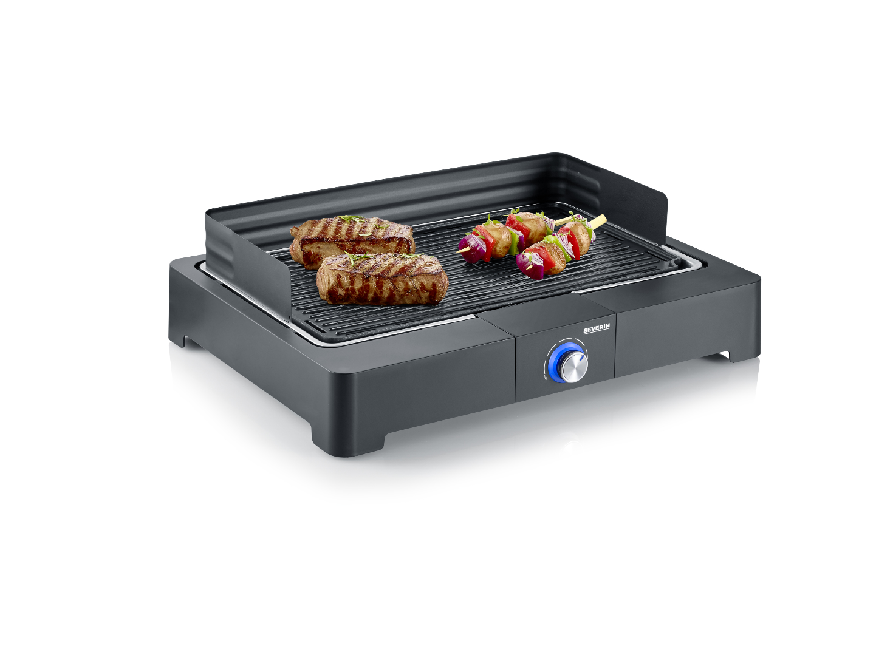

The USP:

- plug-and-grill – Fast grilling enjoyment thanks to short heating-up times - indoor & outdoor
- no risk of burns – SafeTouch housing eliminates the danger of burns on all surfaces
- high-quality grill rack made of stainless for perfect grilling
- easy cleaning due to the modular structure and many removable parts

PG 8562 Tablegrill with grill plate

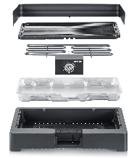 | 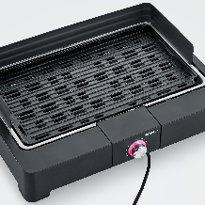 | 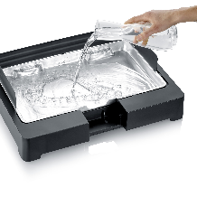
Modular construction:  Many parts are removable and because of this the whole BBQ is easy to clean | Compact table grill  Quickly heated up and flexible to use - indoor and outdoor. | Water in the reflector cup  For easier cleaning, against grease fire and for reduced smoke formation.  The bowl has a capacity of 1,3 l.
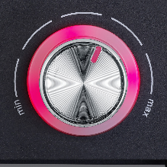
Easy handling
Temperature range can be easily set using the rotary control. The temperature is controlled via the LED ring between blue and red

Details

Important data in overview
Power in Watt | 2.200 W
Colour | Black
Material | Stainless steel / plastic
Grill area | 44,5 x 26 cm (ca. 1150 cm²)
Type | Aluminum die cast grill plate
Wind shield | Yes
Height of the wind shield | 8 cm
Cable length | 1,40 m
Safety switch | Yes
On-Off-Switch | Knob with LED ring
Temperature control | Thermostat controlled heating element
Product dimensions | Width 52 cm, Height15,5 cm, depth 39,5 cm
Product weight | 3,53 kg
Packaging dimensions | 56,5 x 42,5 x 13,2 cm
Weight incl. packaging | 4,25 kg
PU | 2
GTIN-Code | 4008146040115

POS – for a better placement
Aufkleber, Hangtags o.  Ähnliches | Acrylaufsteller | Extra Pressebilder | Produktvideo
NO | NO | NO | NO

Description for Onlineshops

Simple, electrical - eBBQ: Barbecue for indoors and outdoors with the PG 8560 table grill
No matter whether spring, summer, autumn or winter - with this eBBQ table grill you can conjure up juicy food on the dining table all year round! Thanks to the continuous heating spiral, the table grill has an even heat distribution and, when the grill pan is filled with water, ensures little smoke and odor, ideal for use directly at the table or outside.
For indoor and outdoor use
Barbecue fun for indoor and outdoor - Use the versatile table grill optimally for the preparation of delicious food. In addition to the stainless steel grill rack, the rapid heating and high temperatures in particular speak for this practical table grill.
Thermostat controlled heating element
In order to prepare juicy grilled food, it is important to be able to set the ideal temperature. The thermostatically controlled heating element and the temperature controller as well as the continuous heating spiral are available for this.
Easy assembly
This grill impresses with its quick and easy assembly and disassembly and is therefore not only quick to use, but also easy to clean.

