WITH COMBINATION ACCESSORIES - FOR VARIOUS
FLOOR COVERINGS, CARPETS AND PET HAIR
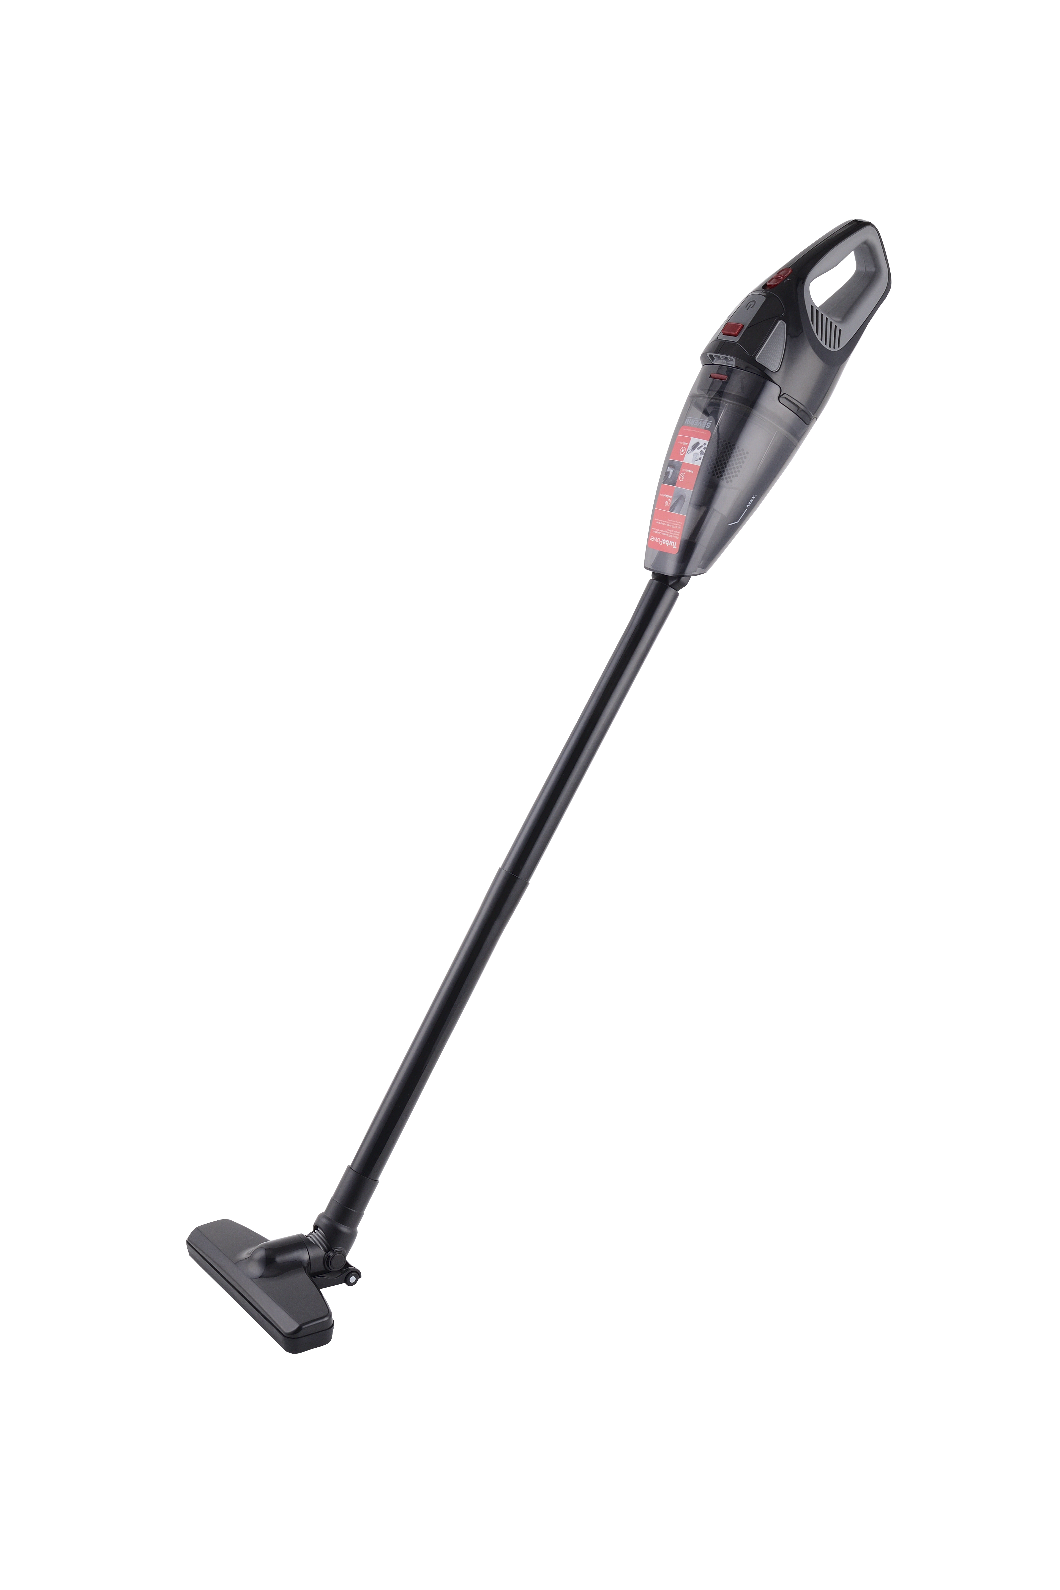

The USP at one view:

- Practical combination
with the extension tube and floor nozzle, the vacuum cleaner can also
serve as a handy floor hoover
- Long runtime of up to 50 minutes (in Eco mode)
owing to a high-capacity 18.5 V lithium-ion battery
- With rotating turbo brush and practical LED lighting
ideal for cleaning upholstery and removing pet hair
- Practical crevice nozzle included
perfect for cleaning cars and hard-to-reach areas
- Stylish carrying bag for storing all accessories
with practical zip fastener and loop for hanging up

HV 7147 Battery handheld vacuum cleaner with combi accessories

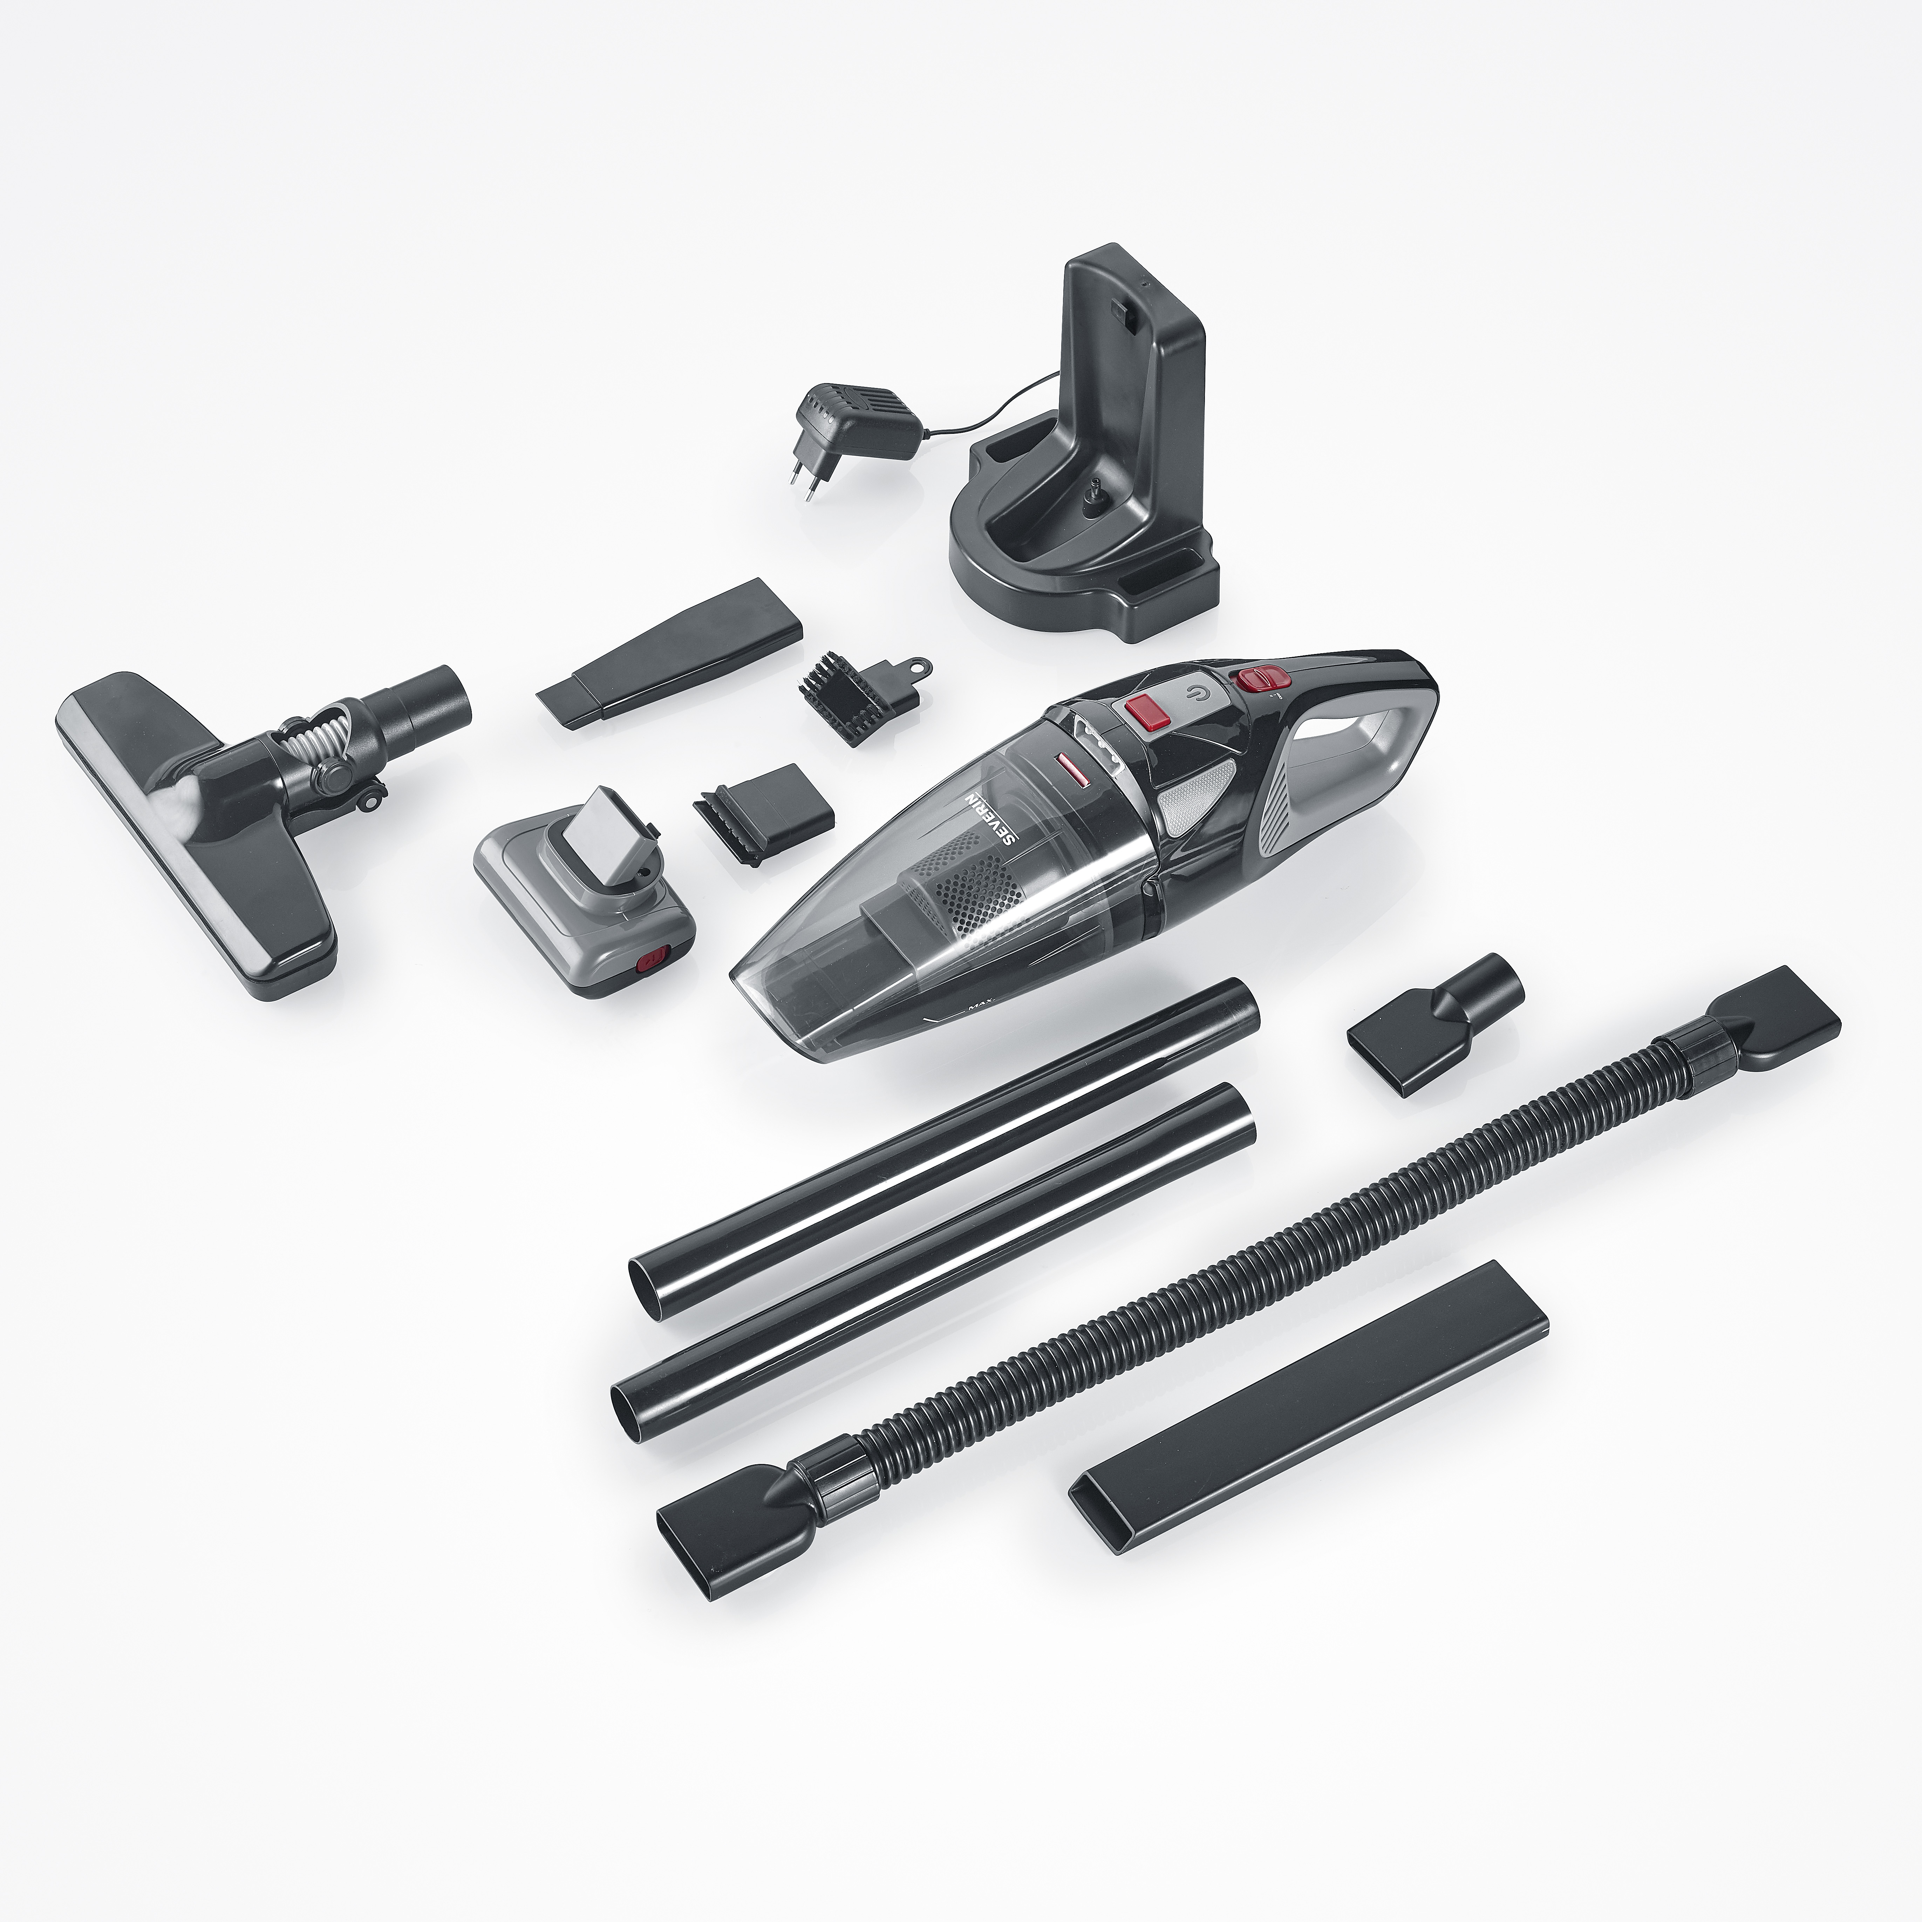 | 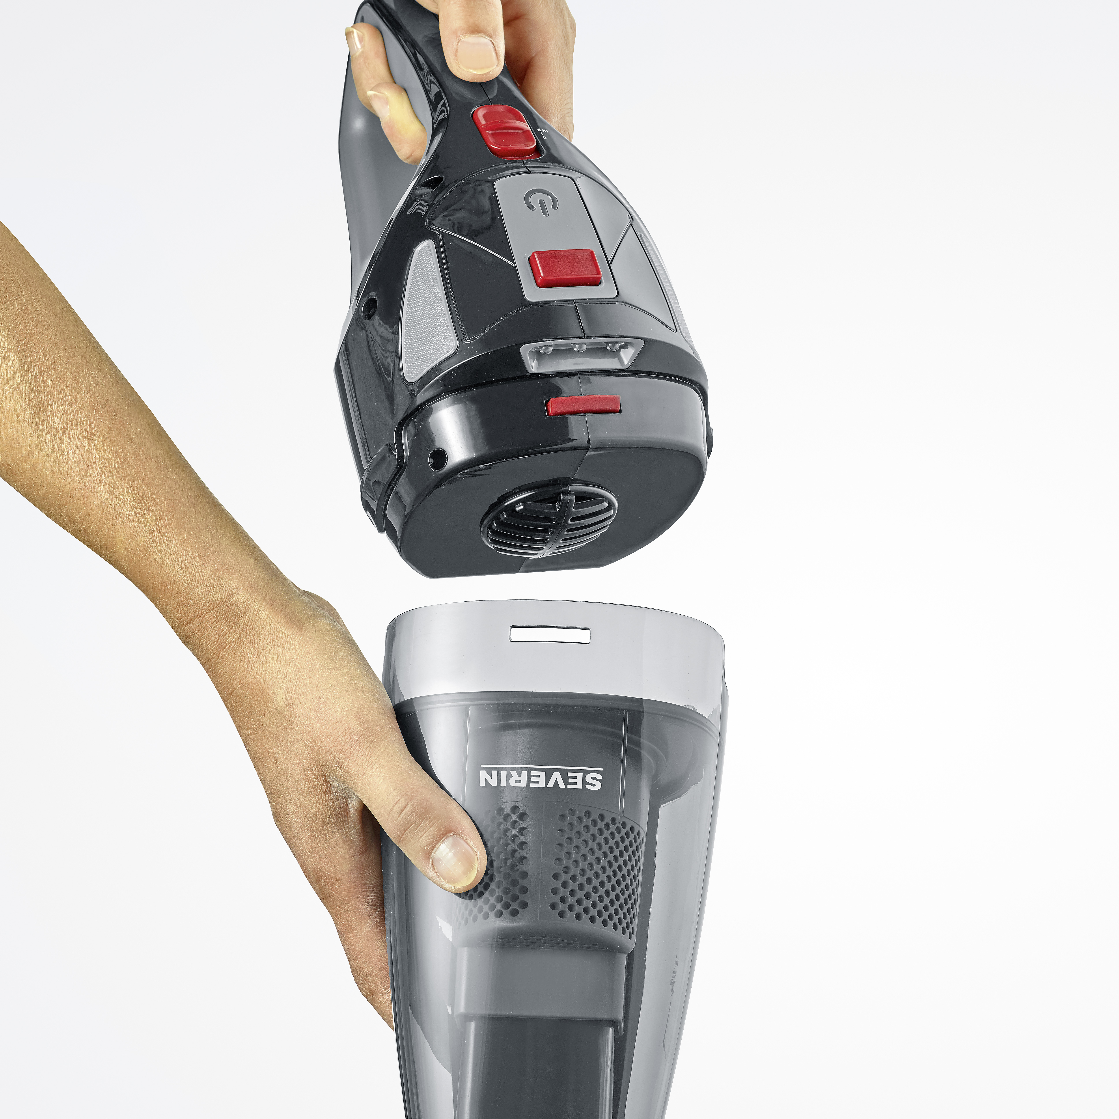
Conveniently convertible  thanks to the extension tube  and the floor nozzle, the  vacuum cleaner can also be used as a handy floor vacuum cleaner. | Convenient cleaning of the dust container  The container system incl. filter  can be easily removed from the  removed and cleaned. | LED lighting included  for difficult to detect dust  and dirt particles in the household.
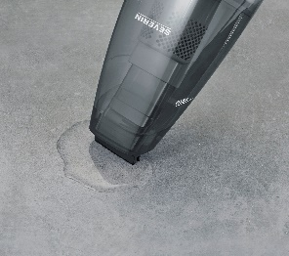 |  | 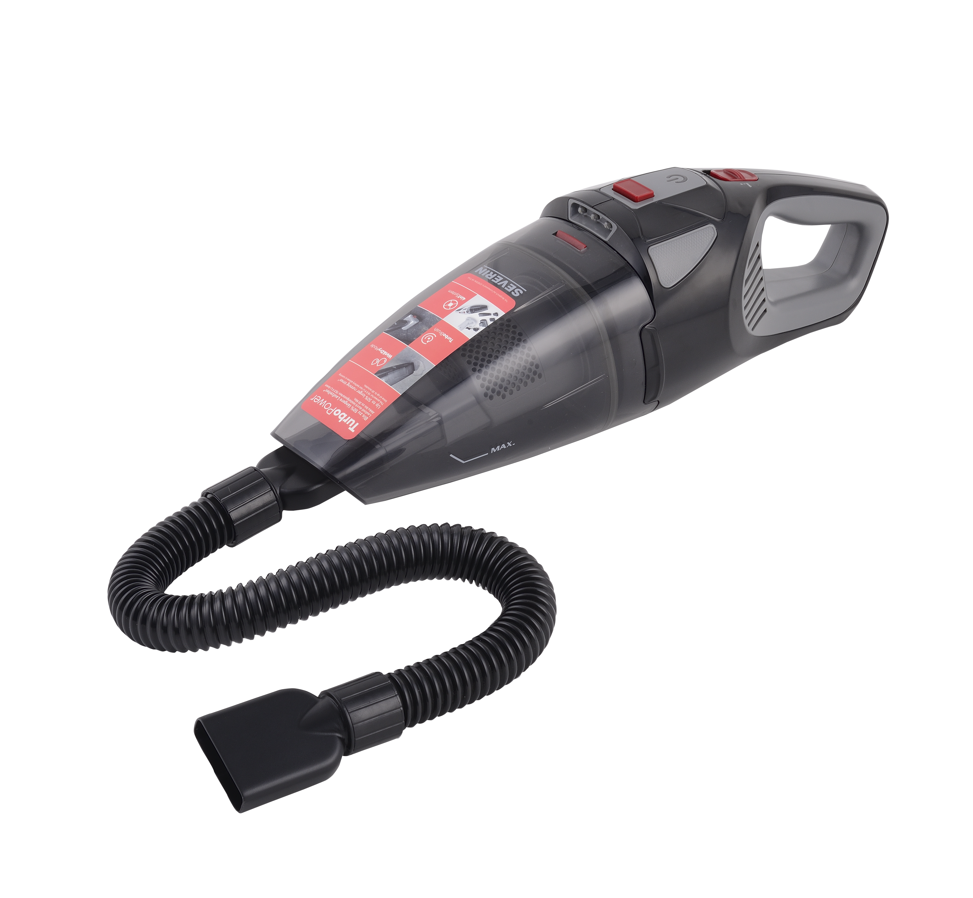
„Wet & Dry“ Function  The exchangeable rubber nozzle  ensures effortless absorption of  of up to 150 ml of liquid. | With rotating turbo brush  ideal for the cleaning of  upholstery and for the removal of  stubborn pet hair. | Effortless car cleaning  thanks to the practical and  flexible crevice nozzle with attachment.
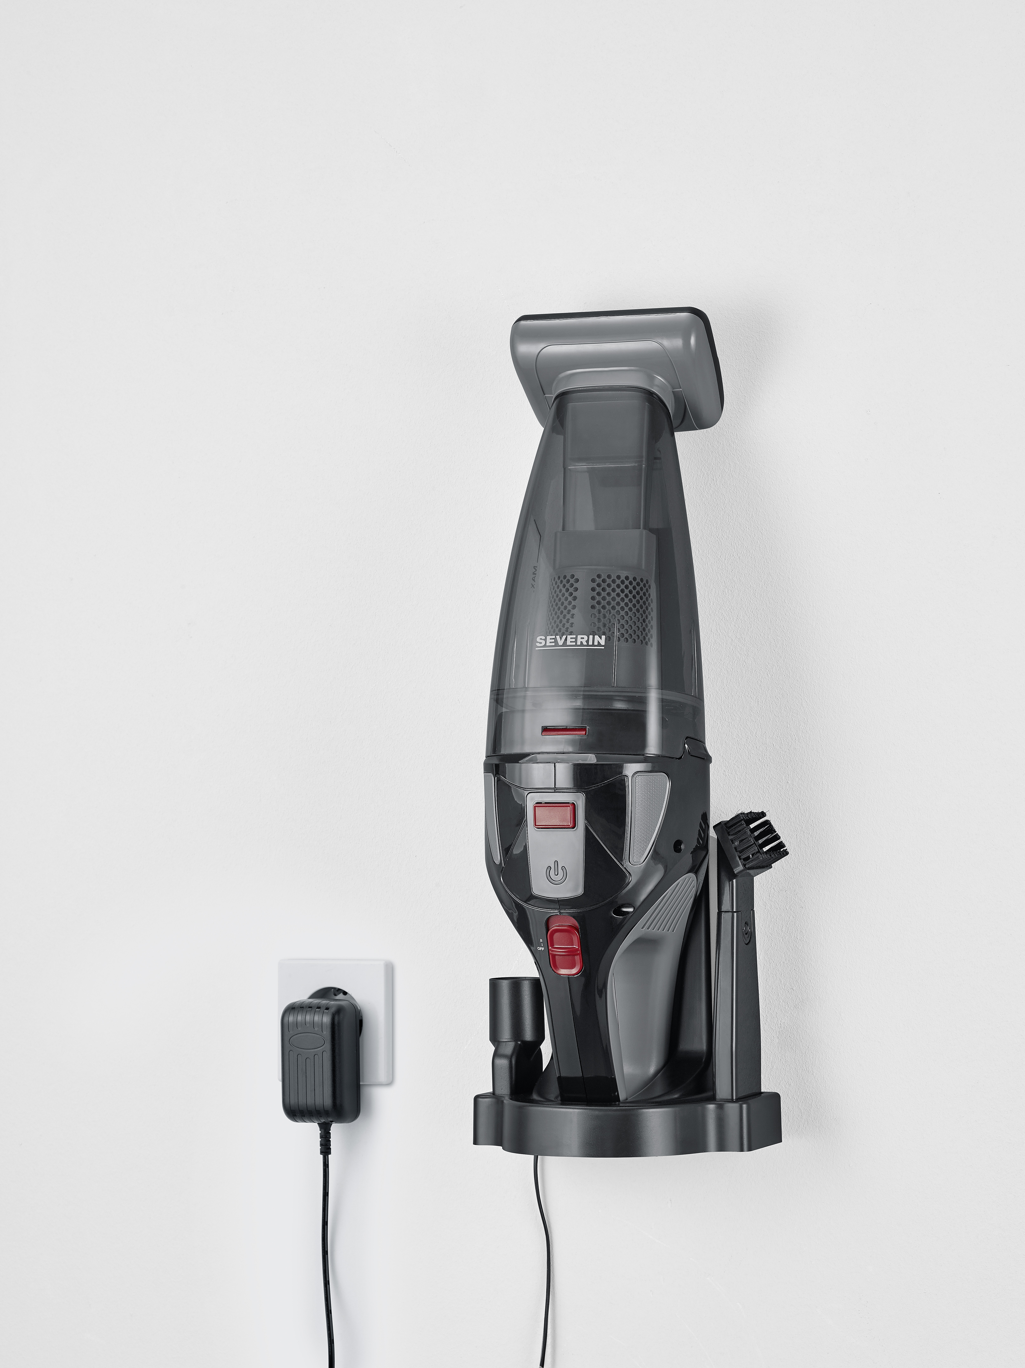
Charging station with accessories  and wall mount  The device can simply be positioned vertically  positioned in the station and  loaded. | High quality carrying bag  for practical storage of the  accessories included in delivery.
Produktdetails

Important data in overview

Li-Ionen Akku | 18,5 V / 2.200 mAh
Charging time | 5 hours
Wattage Max. | 120 W
Capacity dust container | 650 ml
Suction Power | 5,5 kPa
Rotations / Min | 2.500 turns / min
Running time | approx. 20 Min (Power-Mode)  approx. 50 Min (Eco-Mode)
Colour / Material | Black-Grey / Red
Features | Charging indicator with LED  Filtration with filter classification H7
Auto Cut off | Yes
Weight of device | 1,45 kg
Meas. device packaging | 47 x 28 x 20 cm
Meas. incl. Master carton | 50,5 x 42,4 x 49 cm
Meas. of device | 122 x 24 x 13 cm
PU | 4
GTIN-Code | 4008146041846

