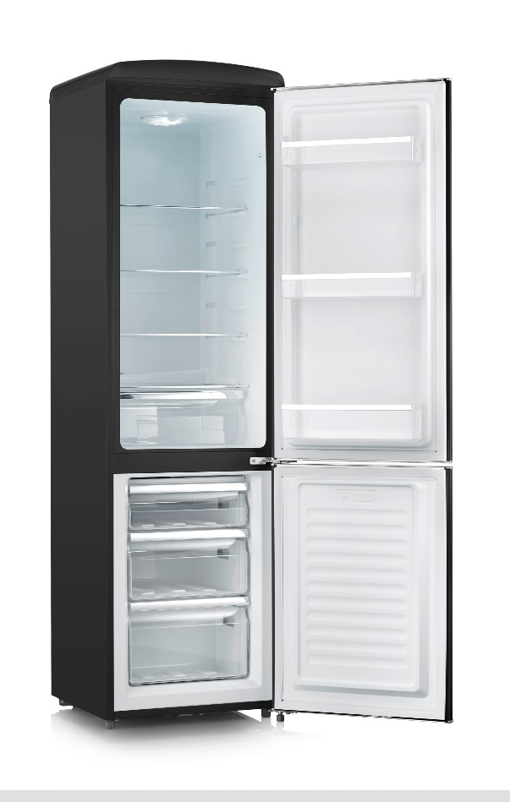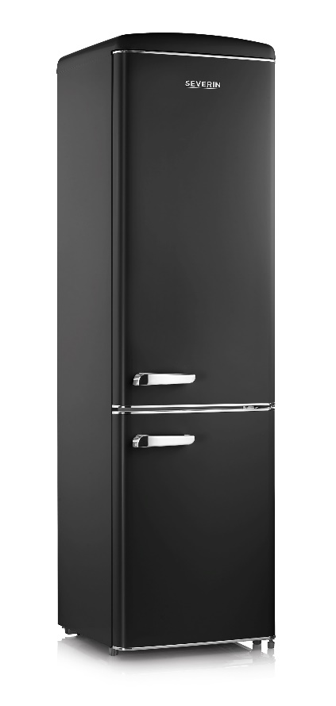

**Logistics data**

* Appliance dimensions: 183 x 55 x 61,5 cm
* Packaging dimensions: 189,5 x 58 x 66 cm
* EAN: 4008146030352

THE HIGHTLIGHT IN EVERY APARTMENT – IN STYLISH RETRO DESIGN

**FURTHER BENEFITS**

* Integrated temperature control on lamp
* 3 x heigh-adjustable safety glass shelves
* 3 x door balconies
* 3 x freezer compartments
* adjustable feet

**For tech enthusiasts**

* Energy efficiency class **E**
* Colour:: **matt black** (8922)
* Capacity:
  + cooling range: 181 L
  + freezing range: 63 L
* Energy consumption: 202 kWh/year
* Noise generation: 40 dB (Soundemissionclass C)
* Climate class: N-ST
* 4* freezer compartment
* Freezing capacity: 4 kg/ 24 hours
* Storage time in case of power failure: 15 h
* Attractive appearance in stylish **retro design** (red, matt black, cream und white)
* **Total net capacity: 244 L** (refrigerator: 181 L, freezer compartment 63 L)
* **High-quality design** with chrome-plated metal door handle, glass shelves, storage trays and door covers
* Modern **LED lighting** for pleasantly bright light and a perfect overview

**RKG 8922**